

Introduction 2
Crawler 3
Find the authors 4
Find the publications 7
Schedule 10
Classification 11
Data preparation 11
Train Test Split 11
Model Selection 12
Model Evaluation 13
Search Engine 15
Pre-processing 15
Indexing 16
Vectorization 16
User Interface 17
Search 17
Comparision 19
Partial Search Query (Stemming/Lemmatizer) 21
Conclusion 22
References 23
Appendix 24

Introduction
This project aims to develop a vertical search engine similar to Google Scholar, but with a specific focus on papers and books published by members of Coventry University (CU). The system will crawl “https://pureportal.coventry.ac.uk/en/persons/” profiles of CU academic employees and index their articles in their profiles to create an inverted index. The system will periodically check for new information, ideally as a scheduled job, to keep the index up-to-date.
From the user's perspective, the search engine will provide an interface similar to Google Scholar's main page. Users can enter their queries or keywords related to the resources they are looking for. The system will display the search results sorted by relevance, following a similar approach to Google Scholar. However, the search engine will exclusively retrieve articles from CU with at least one co-author affiliated with the university.
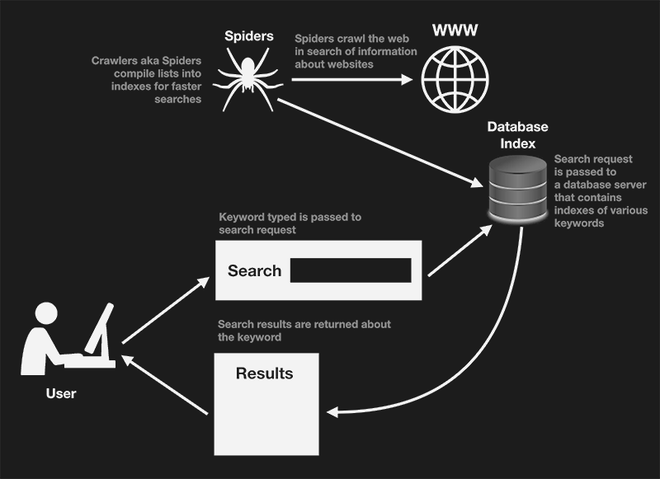
Fig 1: Crawler overview
In addition to the search functionality, the system will also include a subject classification feature. This feature will take a scientific document as input and classify it into one or more categories such as
'Computer Science', ‘Medicine and Dentistry', 'Veterinary Science and Veterinary Medicine' or ‘Engineering', which are all areas of study. The subject classification functionality can be developed as a standalone software or integrated with the search engine.

Crawler
A crawler is a software application that performs automated searches of web documents. Its main purpose is to navigate the internet and create an index, making it particularly useful for search engines. Crawlers are designed to perform repetitive tasks, automating the process of browsing.
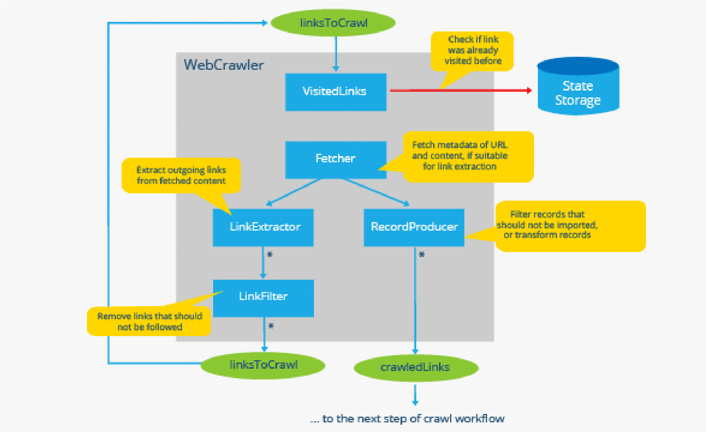
Fig 2: Crawler architecture
Crawlers visit websites and read their pages and other information to create entries for a search engine's index. The primary purpose of a web crawler is to provide users with a comprehensive and up-to-date index of all available online content. By using web crawlers, businesses can keep their online presence (i.e. SEO, frontend optimization, and web marketing) up-to-date and effective. Search engines like Google, Bing, and Yahoo use crawlers to properly index downloaded pages so that users can find them faster and more efficiently when searching. Without web crawlers, there would be nothing to tell them that your website has new and fresh content.

Find the authors
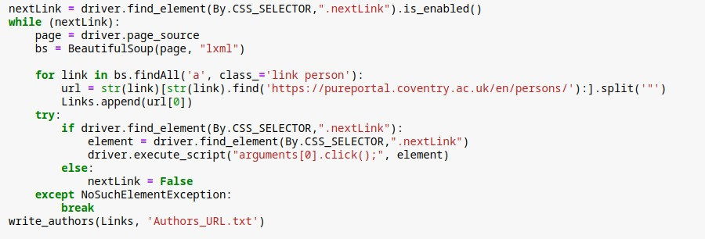
Fig 3: Finding arthors
Firstly store all the author’s links to a text file to crawl in the latter phase. This function checks if there is a next button, and will iterate to store the link for “a” tag from the browser until there is no next button.
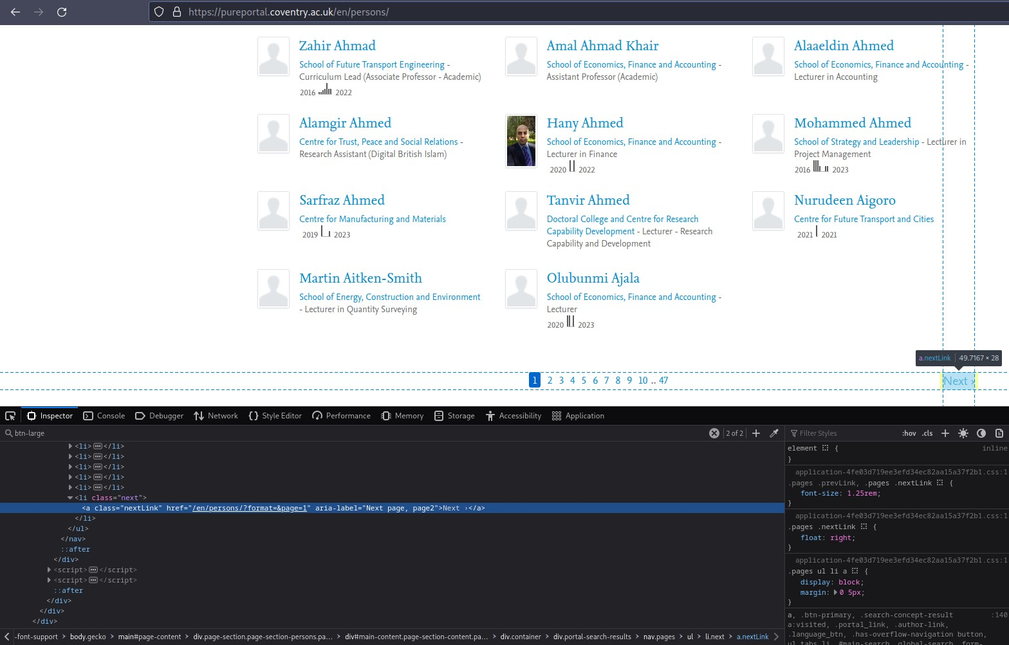
Fig 4: Crawler finding next pages
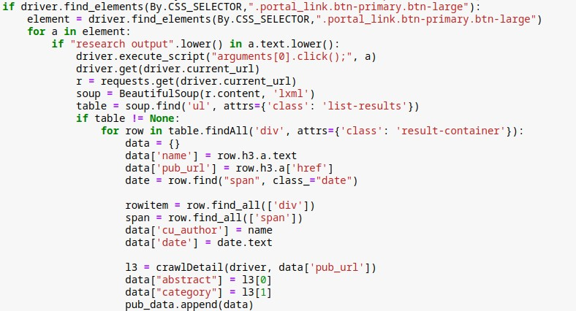
Fig 5: Crawler source code to find more publications
Next step is to go through all the links of the author to retrieve the data of the publications. There are two cases to get publication. The website shows “View all x research outputs” if the author has more than 5 publications. If the case is true, it clicks to expand and get all the data of publication.
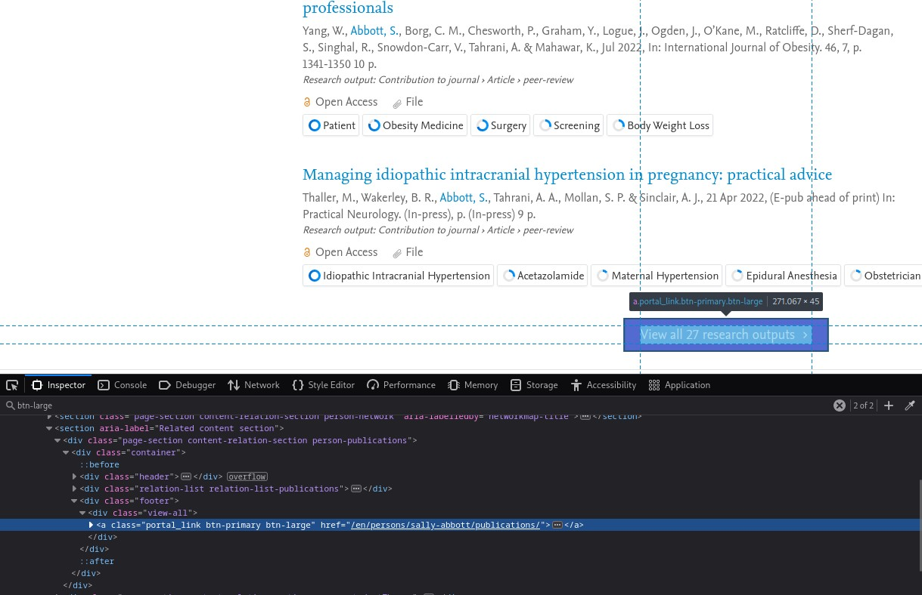
Fig 6: Crawler to find more publications
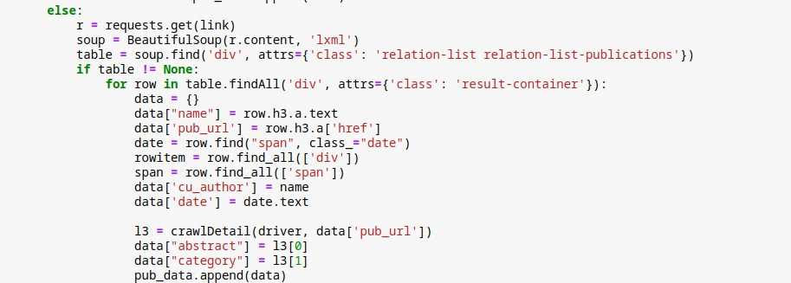
Fig 7: Crawler to find general publications

Fig 8: Crawler’s behavior to finding html compoment
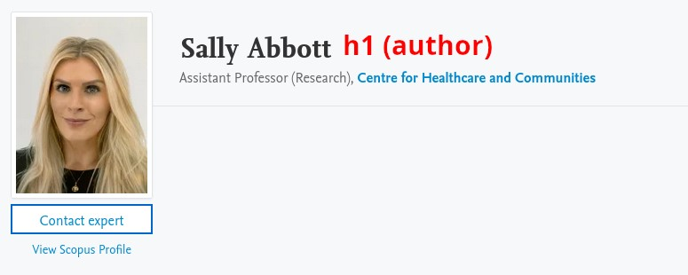
Fig 9: Crawler’s behavior to finding html compoment 2

Find the publications
The publication is further crawled to get extra information such as abstract and the fingerprints of an individual publication.
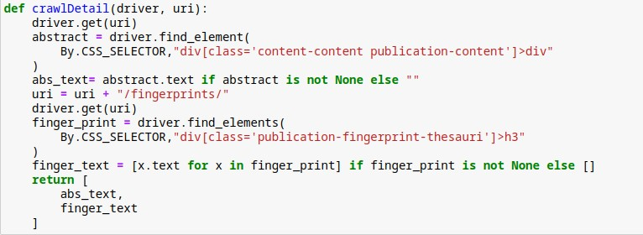
Fig 10: Crawler source code to find abstract and fingerprints The content of Abstract from the following figure is extracted for further data collection.

Fig 11: Crawler finds abstract from a publication
The final step is to get the categorical data which is accessed by redirecting to the fingerprint section. From the following figure, the values “Neuroscience” and “Psychology” are extracted.
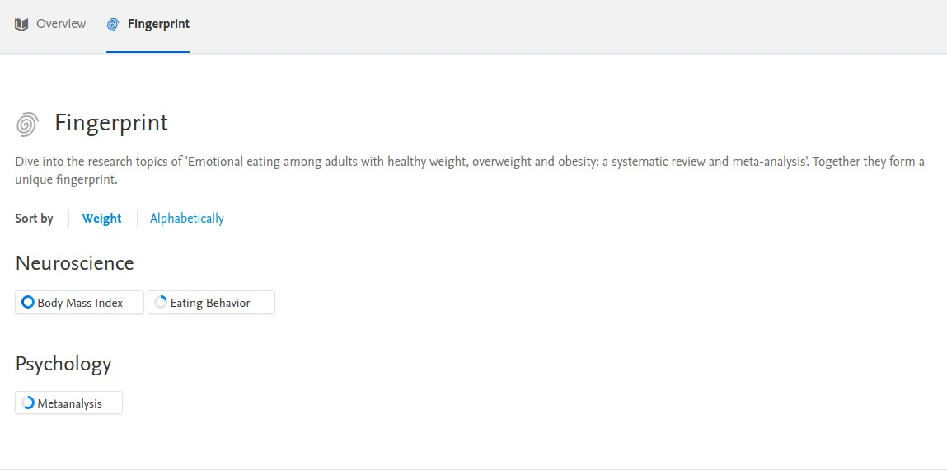
Fig 12: Crawler redirects and finds fingerprint from a publication

Schedule
Information retrieval often involves frequent fetching data from external sources, such as websites or APIs. By using a scheduler, it can be ensured that the retrieval task runs at specific intervals, ensuring that the most up-to-date information is available.
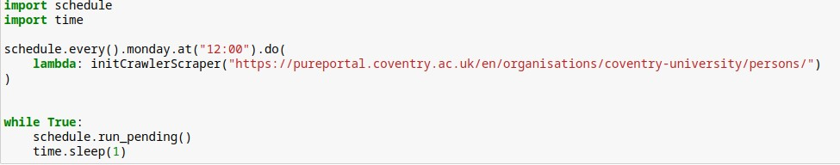
Fig 13: Schedule to crawl every week
The code provided sets up an automated schedule to run a specific function every Monday at noon. The function is responsible for collecting information from a website. The code keeps checking if it's time to run the function, and when the time comes, it executes the function. It then waits for a short time before checking for the next scheduled task. This process continues indefinitely.

Classification

Data preparation
From the collected data, the categorical list of values are splited into a bitmap. In a bitmap, each bit represents a specific element or attribute, and its value indicates the presence or absence of that element or attribute. If the bit is set to 1, it means the element is present in the set, and if it is set to 0, it means the element is absent.
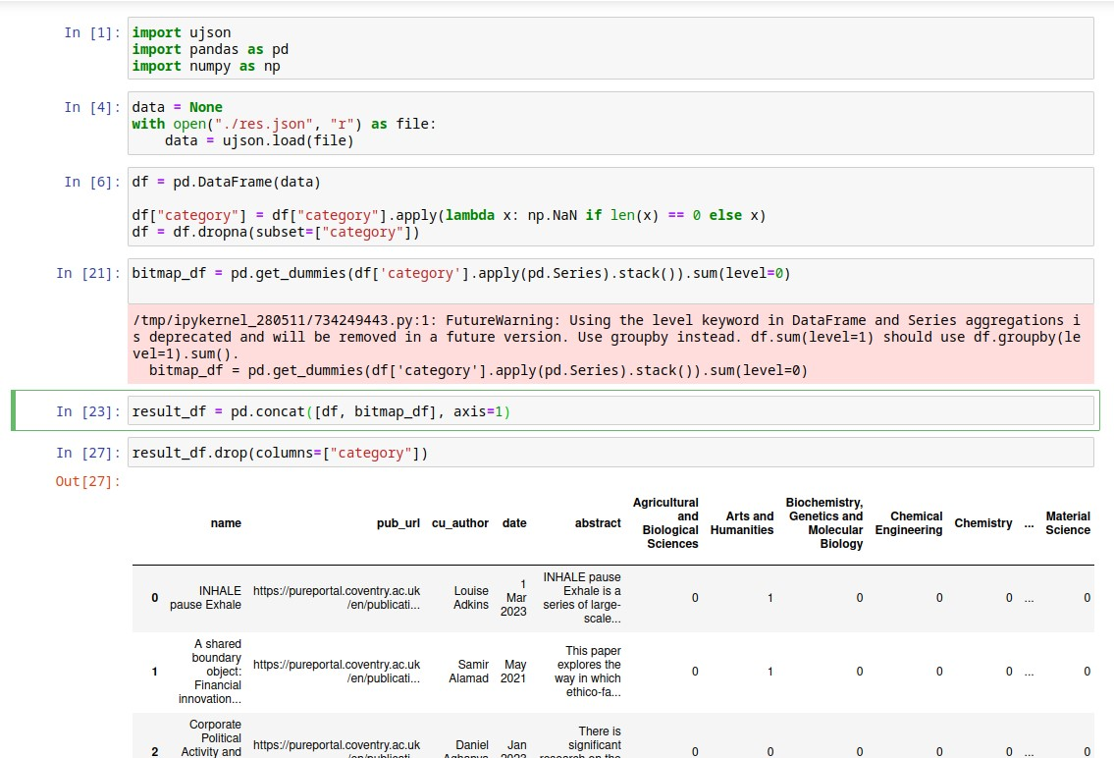
Fig 14: Data preparation and bitmap for classifier

Train Test Split
The DataFrame is splited into train_data and test_data, with a test size of 20% of the total data. The random_state parameter is set to 42 to ensure reproducibility of the split.
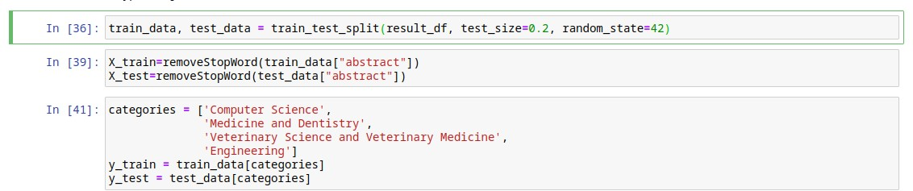
Fig 15: Data splitting
The categories of interest for classification are defined as a list called categories. These categories represent the target variables. The corresponding category labels for the training and testing sets are extracted from the “train_data” and “test_data”, respectively, using the specified category names. The category labels are stored in y_train and y_test.

Model Selection
The pipeline consists of two main steps: tfidf and nb:
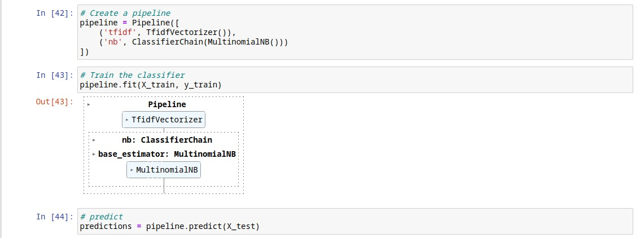
Fig 16: Model pipelining
The TfidfVectorizer transforms the raw text data into a numerical representation called TF-IDF (Term Frequency-Inverse Document Frequency). It calculates the importance of each word in a document relative to the entire corpus. This step helps to capture the significance of words in distinguishing between different documents.
The next step represents the classifier used in the pipeline, which is a ClassifierChain wrapped around a MultinomialNB (Multinomial Naive Bayes) model. The ClassifierChain is a multi-label classifier that builds a chain of binary classifiers to predict multiple labels simultaneously. MultinomialNB is a probabilistic classifier suitable for text classification tasks.

Model Evaluation
The following calculates the accuracy of the model by comparing the predicted labels (predictions) with the true labels (y_test). The accuracy score indicates the proportion of correctly predicted labels out of the total number of labels. The F1 Scrore is a measure of the model's accuracy that considers both precision and recall. It is computed for each category (micro-average) and provides an overall measure of the model's performance. The classification_report function generates a comprehensive report that includes precision, recall, and F1-score for each category, as well as support (the number of samples) for each category. It also provides average metrics such as macro average, weighted average, and samples average.
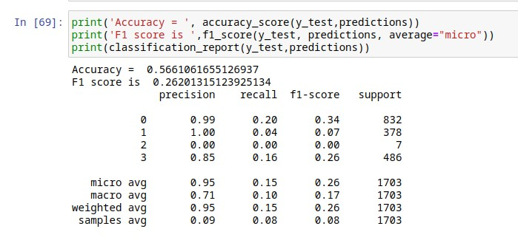
Fig 17: Model accuracy score
In the given example, the accuracy of the model is 0.5661, indicating that 56.61% of the labels were predicted correctly. The F1 score is 0.2620, which represents a trade-off between precision and recall. The macro average, weighted average, and samples average provide aggregated metrics across all categories.
The confusion matrix describes the performance of a classification model by displaying the counts of true positive, true negative, false positive, and false negative predictions.
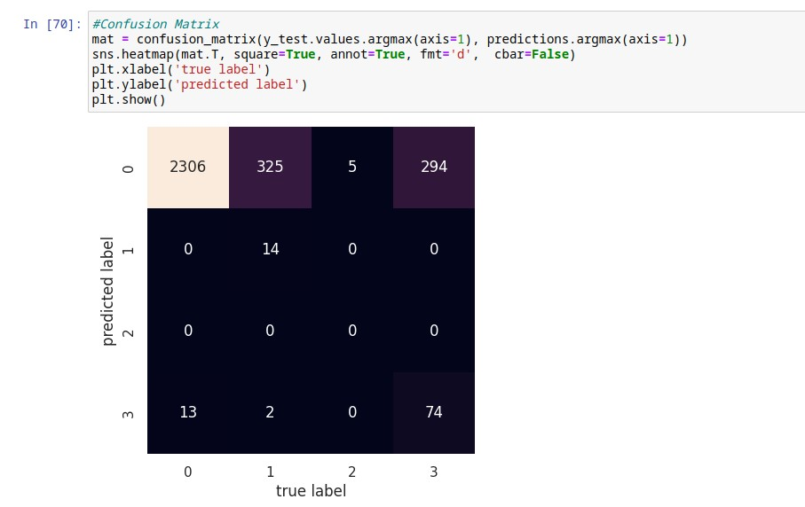
Fig 18: Model confusion matrix
The first row indicates the predictions for the first class. It shows that there are 2306 true positive predictions (correctly predicted as the first class), no false positive predictions (incorrectly predicted as the first class), no false negative predictions (incorrectly predicted as a different class), and 13 true negative predictions (correctly predicted as a different class). The other 3 rows or labels can be interpreted the same.

Search Engine

Pre-processing
First, it converts the text to lowercase using the lower() method. This ensures that the text is treated uniformly and case-insensitive operations can be performed. Next, it uses regular expressions (re.sub()) to remove any non-alphabetic characters from the text, keeping only letters. This step helps eliminate punctuation, symbols, and other non-alphabetic characters that may not be relevant for subsequent processing. The text is then split into individual words using the split() method, creating a list of words. In the following step, a list comprehension is used to filter out any stop words from the list of words. Stop words are common words such as "a," "the," or "and," which typically do not carry significant meaning and are often removed to focus on more informative content. The stop_words variable refers to a set of stop words, which is typically predefined.
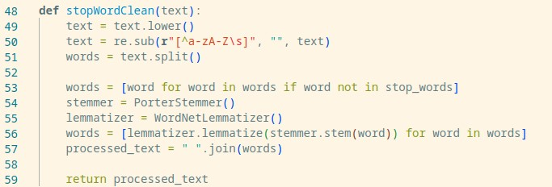
Fig 19: Query preprocessing
After filtering out stop words, the function initializes a stemmer (PorterStemmer) and a lemmatizer (WordNetLemmatizer) to perform stemming and lemmatization on the remaining words. Stemming is the process of reducing words to their base or root form (e.g., "running" becomes "run"), while lemmatization aims to convert words to their dictionary or base form (e.g., "better" becomes "good"). Both techniques help consolidate different forms of words into their common representations, which can aid in information retrieval tasks. Finally, the processed words are joined back into a single string using the join() method, with each word separated by whitespace. This creates the processed_text, which is the cleaned and preprocessed version of the original text.

Indexing
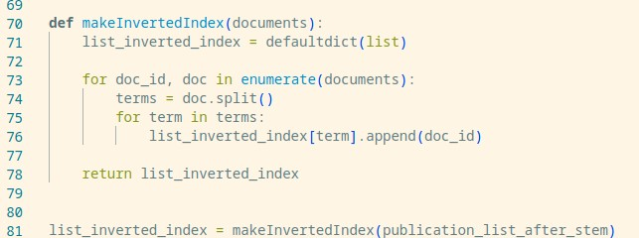
Fig 20: Inverted index implementaion
The function initializes an empty “list_inverted_index” using the defaultdict class, which automatically creates a default value (an empty list) for any missing key. This ensures that every term encountered in the documents will have an associated list in the inverted index, even if the term doesn't appear in some documents. The function then iterates over each document in the documents. For each document, the text is split into individual terms (words), assuming that terms are separated by whitespace. Next, the function iterates over each term in the document. For each term, it appends the corresponding document index (doc_id) to the list associated with that term in the list_inverted_index. If a term appears multiple times in the same document, its document index will be appended multiple times to the list. Finally, the function returns the “list_inverted_index”, which now contains the mapping of terms to the documents they appear in. This inverted index can be used for efficient information retrieval tasks, such as finding documents that contain specific terms or performing full-text search.

Vectorization
TF-IDF (Term Frequency-Inverse Document Frequency) index is a numerical representation used to measure the importance of a term in a document or a collection of documents. It considers the term's frequency within a document (TF) and its rarity across the collection (IDF). By calculating TF-IDF weights, the index helps rank documents based on their relevance to a query. Search engines commonly utilize TF-IDF indexing for information retrieval.
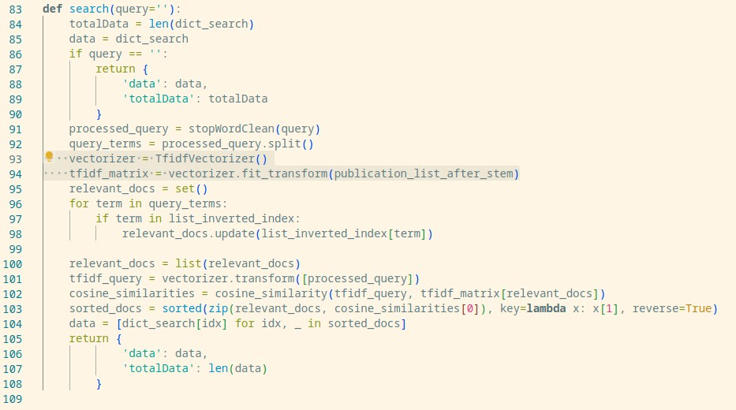
Fig 21: TFIDF implementaion
When a user enters a query, the search engine calculates the TF-IDF scores for the query terms against the documents in its database. The documents with higher TF-IDF scores for the query terms are considered more relevant and are displayed as the top search results. For example, consider a user searching for "machine learning algorithms." The search engine calculates the TF-IDF scores for the terms "machine," "learning," and "algorithms" across its indexed documents. The documents containing these terms frequently (high TF) but appearing in fewer documents overall (high IDF) will receive higher TF-IDF scores. As a result, documents that specifically discuss machine learning algorithms will be ranked higher in the search results.
TF-IDF enables search engines to accurately determine the relevance of documents to a user's query, improving the precision and effectiveness of search results. It helps retrieve documents that contain the specific terms the user is looking for and minimizes the impact of common terms that may appear in many search results.

User Interface

Search
The search UI provides optimal input for users to enter a search query. When a text is empty it will try to show all the data in the database, if the user inputs data the search query will show the optimal search results. The database saved for the model is vectorized in a tfidf vector and the search query will be vectorized in the same way. Aftwards the cosine similarity between the vectors are measured to find the matching results.
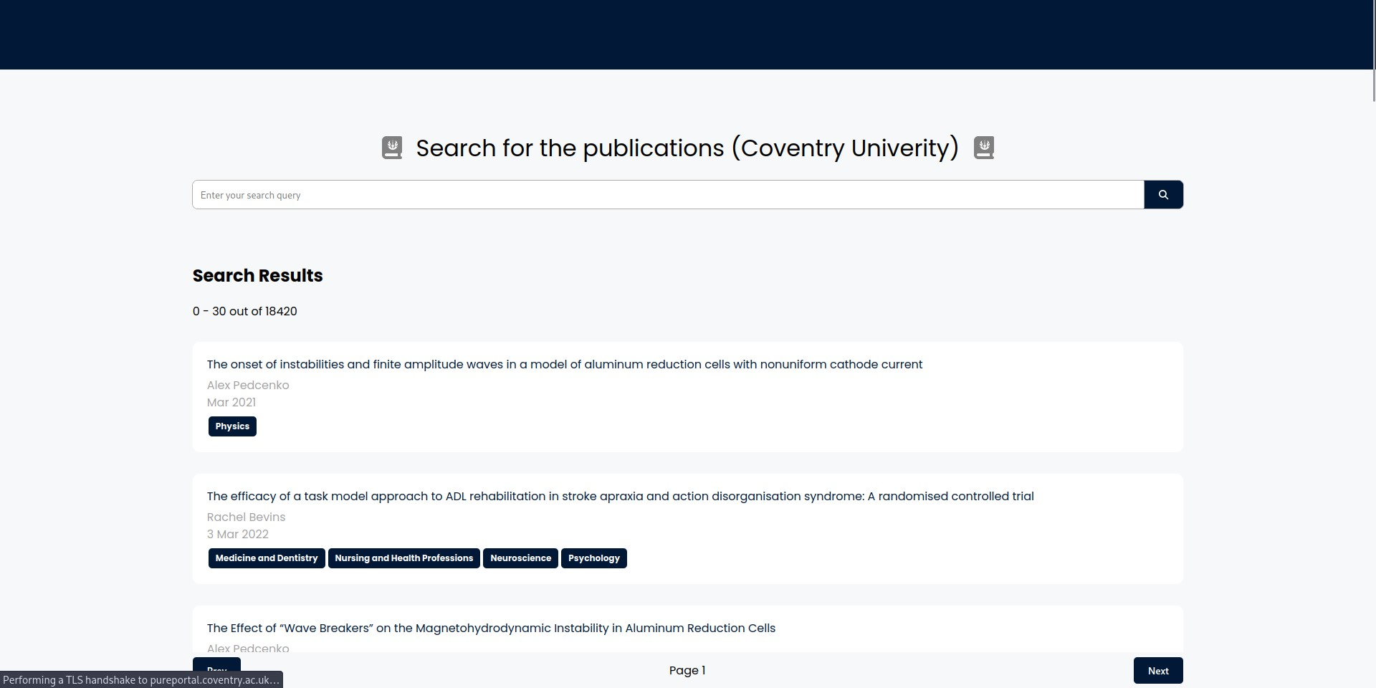
Fig 22: Search interface The search result will be redirected to its original source if clicked as follows.

Fig 23: Search redirection to original

Comparision
The following search query is the comparison between the project’s search interface and the google scholar search interface.
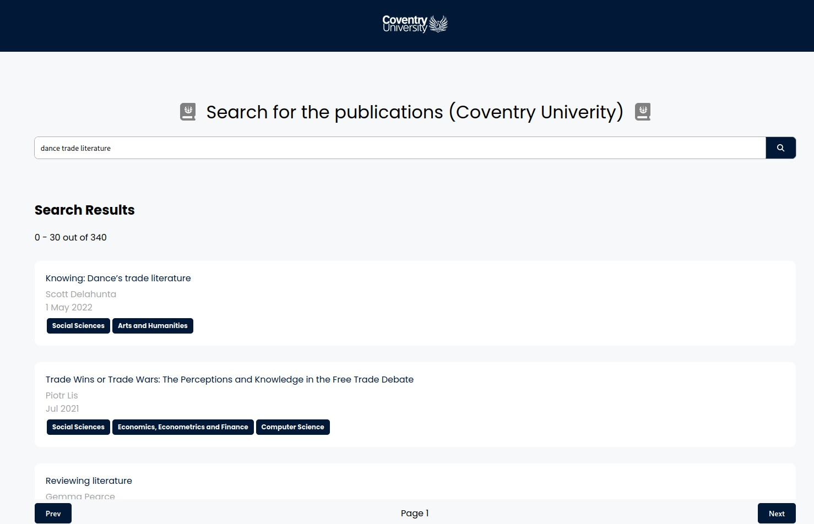
Fig 24: Search comparison (interface)
Here the top result shows the “Knowing: Dance’ trade literature”, the same seach query has been compared to google scholar’s search engine.
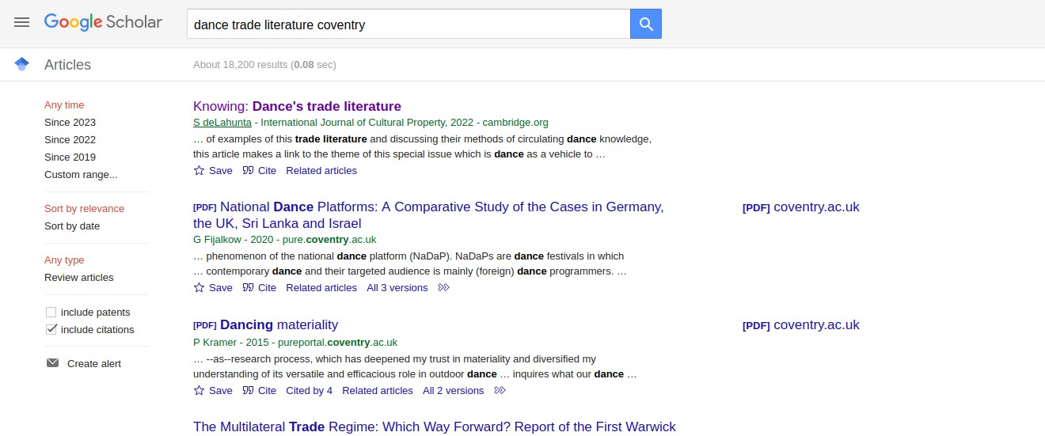
Fig 25: Search comparison (google scholar)
The result shows a similar search result, the punctuation and the case of search params has been handled in the pre-processing of the seach engine to get the optimal results.

Partial Search Query (Stemming/Lemmatizer)
The following comparison shows the advantage of using stemming and lemmantizer on the search query. The search query tested is to find the top related publication for “develop digital competence framework digital teach”.
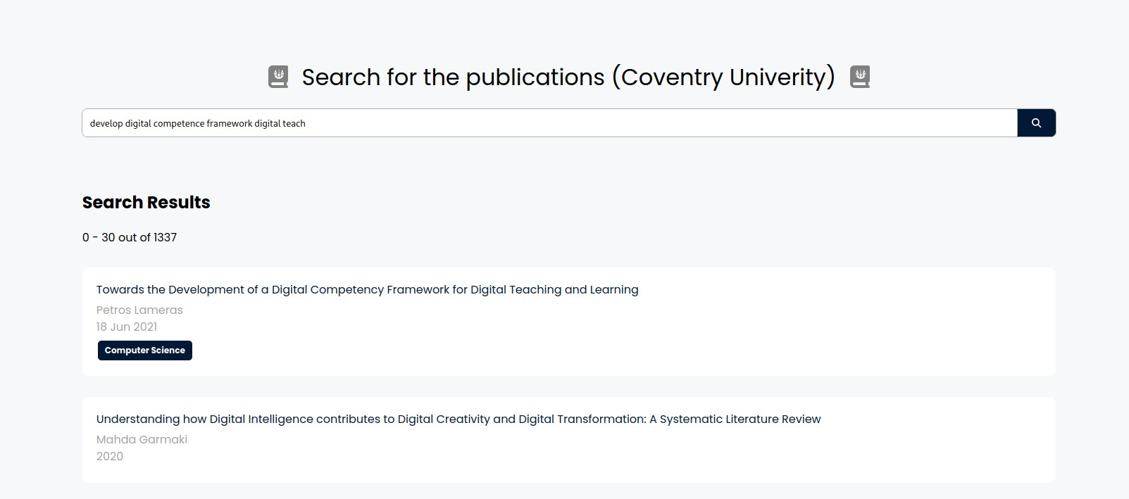
Fig 26: Search comparison (interface) 2
The stemming of the word “development”, “teaching” can be searched with the root word “develop” and “teach”. Likewise the lemmanted word for “competency” with “competence” will still be able to search the related contents.
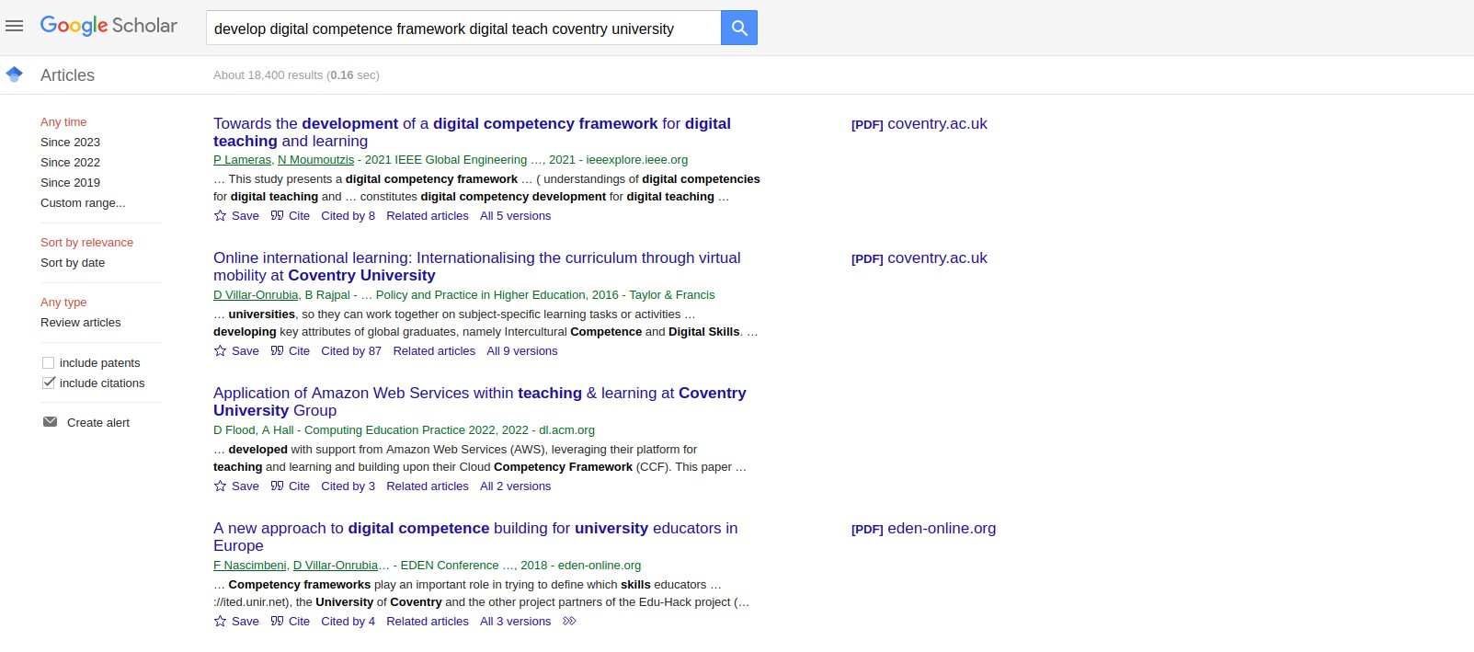
Fig 27: Search comparison (google scholar) 2

Conclusion
This project focuses on developing a vertical search engine for accessing papers and books published by Coventry University (CU) members. It employs web crawling techniques to extract data from CU academic profiles and indexes it using an inverted index structure. Users can enter queries related to their desired resources, and the system retrieves search results ranked by relevance, exclusively focusing on CU-affiliated articles. The search engine can be customized for specific disciplines. Additionally, the system includes a subject classification feature and utilizes a crawler for web data retrieval. With a scheduling mechanism in place, the system ensures timely updates for the most up-to-date information.

References
Crawler. What is a web crawler and how does it work? (n.d.). https://en.ryte.com/wiki/Crawler
Web crawlers - top 10 most popular. KeyCDN. (n.d.). https://www.keycdn.com/blog/web-crawlers
Products, D. (2022, October 4). Text preprocessing techniques in Natural Language Processing. Medium. https://medium.com/@dataproducts/text-preprocessing-techniques-in-natural-language-processing-19a84 0bb7a4f
Author: Fatih Karabiber Ph.D. in Computer Engineering, Fatih Karabiber Ph.D. in Computer Engineering, Psychometrician, E. R., & LearnDataSci, E. B. F. of. (n.d.). TF-idf - term frequency-inverse document frequency. Learn Data Science - Tutorials, Books, Courses, and More.
https://www.learndatasci.com/glossary/tf-idf-term-frequency-inverse-document-frequency/
Multi-label classification with Scikit-MultiLearn. Section. (n.d.). https://www.section.io/engineering-education/multi-label-classification-with-scikit-multilearn/
Goyal, C. (2021, June 22). Part 4: Step by step guide to master NLP - text cleaning techniques. Analytics Vidhya.
https://www.analyticsvidhya.com/blog/2021/06/part-4-step-by-step-guide-to-master-natural-language-pro cessing-in-python/
F1 score in Machine Learning: Intro & Calculation. V7. (n.d.). https://www.v7labs.com/blog/f1-score-guide
Beheshti, N. (2022, February 10). Guide to confusion matrices & classification performance metrics.
Medium.
https://towardsdatascience.com/guide-to-confusion-matrices-classification-performance-metrics-a0ebfc08 408e

Appendix
https://github.com/albertmaharjan94/information-retreival https://youtu.be/_kBoB7SuTb4

